EXP 4 : GENERATION AND ANALYSIS OF FREQUENCY MODULATED (FM) AND OF PHASE MODULATED (PM) SIGNALS USING MATLAB

SOFTWARE USED : MATLAB SOFTWARE

CODE :
clc; clear; close all

Fs=1e5; t=0:1/Fs:2e-3;
fm=1e3; fc=1e4; Am=1; Ac=1;
m=Am*cos(2*pi*fm*t);

% FM and PM
FM=Ac*cos(2*pi*fc*t+2*pi*5*sin(2*pi*fm*t));
PM=Ac*cos(2*pi*fc*t+pi/2*sin(2*pi*fm*t));

subplot(3,1,1),plot(t,m),grid on
title('Message Signal')

subplot(3,1,2),plot(t,FM),grid on
title('FM Signal')

subplot(3,1,3),plot(t,PM),grid on
title('PM Signal')

MODEL GRAPH :
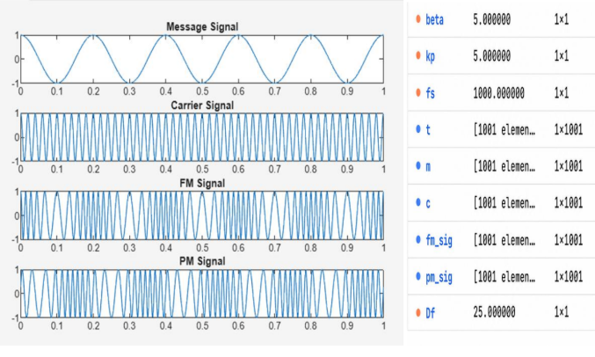
RESULT :
